Students’ Perception Study

In the total number of respondents, the share of the courses, namely, B.Sc. (Hons) Zoology, B.A. Program/ Multidisciplinary, B.A. (Hons) Hindi and B.A. (Hons) Philosophy are at the higher end ranging between 9 to 11% individually in descending order. The share of the courses, namely, B.El.Ed, B.A. (Hons) Economics, Geography, Sociology and Bengali are at the lower end ranging between 3 to 1% individually in descending order.

# **General perception/information**

## Accessibility towards economic aid provided by the college

Around 67% of the total respondents “did not apply” for any economic aid provided by the College. Around 11.4% of the total respondents “applied but was not granted”. Around 19% of the total respondents mentioned that they “would have applied, but had no information”. The students who actually obtained any economic aid provided by the College are very less.

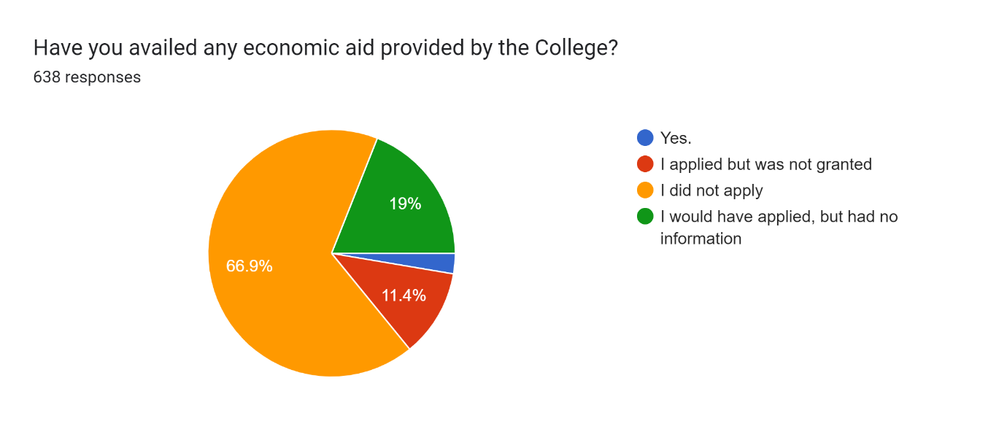

|  |  |  |  |  |  |
| --- | --- | --- | --- | --- | --- |
| **Course of Study** | **Did not apply any economic aid** | **I would have applied, but had no information** | **I applied but was not granted** | **Yes** | **Total** |
| B.A. (Hons) Bengali | 54.5 | 45.5 | 27.3 | 0.0 | 100 |
| B.A. (Hons) Economics | 58.8 | 11.8 | 0.0 | 5.9 | 100 |
| B.A. (Hons) English | 76.9 | 23.1 | 0.0 | 0.0 | 100 |
| B.A. (Hons) Geography | 92.9 | 0.0 | 0.0 | 7.1 | 100 |
| B.A. (Hons) Hindi | 60.9 | 23.4 | 14.1 | 0.0 | 100 |
| B.A. (Hons) History | 61.5 | 26.9 | 7.7 | 3.8 | 100 |
| B.A. (Hons) Music | 100.0 | 0.0 | 0.0 | 0.0 | 100 |
| B.A. (Hons) Philosophy | 67.2 | 18.0 | 8.2 | 4.9 | 100 |
| B.A. (Hons) Political Science | 69.6 | 21.7 | 4.3 | 0.0 | 100 |
| B.A. (Hons) Sanskrit | 62.5 | 20.8 | 12.5 | 4.2 | 100 |
| B.A. (Hons) Sociology | 78.6 | 21.4 | 0.0 | 0.0 | 100 |
| B.A. Program/ Multidisciplinary | 67.7 | 16.9 | 13.8 | 1.5 | 100 |
| B.El.Ed | 78.9 | 15.8 | 5.3 | 0.0 | 100 |
| B.Sc. (Hons) Botany | 53.5 | 27.9 | 14.0 | 4.7 | 100 |
| B.Sc. (Hons) Chemistry | 61.4 | 13.6 | 15.9 | 0.0 | 100 |
| B.Sc. (Hons) Mathematics | 69.2 | 10.3 | 15.4 | 2.6 | 100 |
| B.Sc. (Hons) Physics | 60.9 | 21.7 | 17.4 | 0.0 | 100 |
| B.Sc. (Hons) Zoology | 68.1 | 12.5 | 13.9 | 2.8 | 100 |
| B.Sc. Life Sciences / Multidisciplinary | 73.5 | 8.8 | 11.8 | 5.9 | 100 |
| B.Sc. Physical Sciences with Computer/ Multidisciplinary | 45.5 | 36.4 | 9.1 | 9.1 | 100 |
| Not Responded (i.e. Not Disclosed the Department Name) | 71.4 | 14.3 | 14.3 | 0.0 | 100 |
| **Mean** | **68.3** | **18.6** | **9.8** | **2.5** |  |
| **Median** | **67.7** | **18.0** | **11.8** | **1.5** |  |

In 50% of the courses more than 67% respondents had imperfect information regarding the provision of economic aid. In courses, namely, B.A. (Hons) Sanskrit, Sociology, Political Science, English, Hindi, History, Bengali, B.Sc. (Hons) Physics, Botany and B.Sc. Physical Sciences with Computer/ Multidisciplinary there are at least 20% of students in each course who have expressed their inability to apply due to lack of information. In this regard, lack of information is mostly expressed to be prevailed in B.Sc. Physical Sciences with Computer/ Multidisciplinary and B.A. (Hons) Bengali with 36.4% and 45.5% respectively. Lack of information was not reported at all by B.A. (Hons) Geography and Music. In 10 out of 21 courses, no students have received any grants.

## Membership of any Extra-curricular Society/ Club in college

Nearly 60% of the respondents are members of any extracurricular society/club.

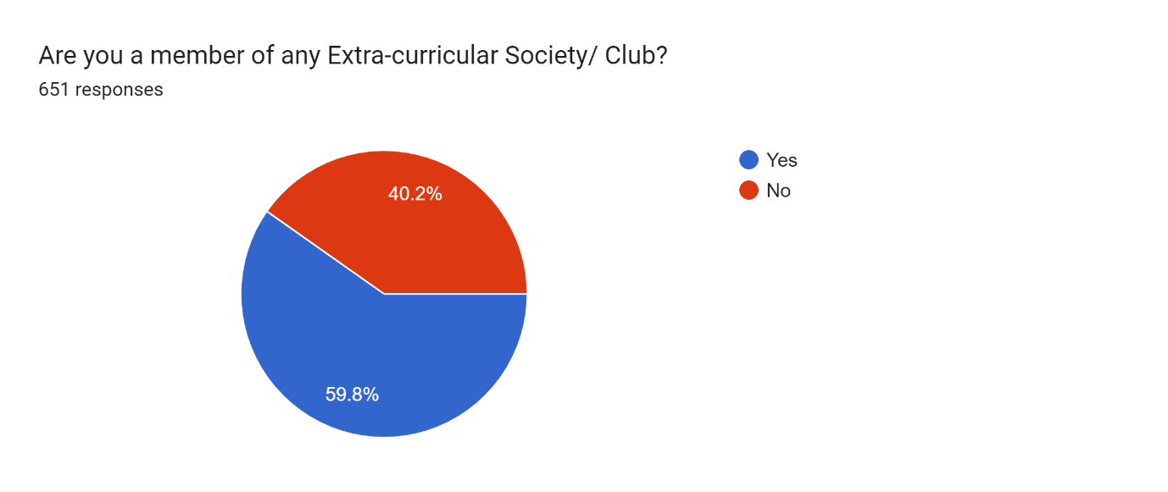

|  |  |  |
| --- | --- | --- |
| **Courses** | **Member of any society or club (% in total respondent course-wise** | **Inference** |
| B.A. (Hons) Music Count | 100.0 | Courses where at least 70% students are member     Participation in extracurricular society is large. |
| B.A. (Hons) Political Science Count | 79.2 |
| B.A. (Hons) English Count | 74.1 |
| B.Sc. (Hons) Physics Count | 70.8 |
| B.A. (Hons) Economics Count | 66.7 | Courses 50-70% students are member       Participation in extracurricular society is moderate |
| B.A. (Hons) History Count | 66.7 |
| B.A. Program/ Multidisciplinary Count | 66.7 |
| B.Sc. Life Sciences / Multidisciplinary Count | 65.7 |
| B.Sc. (Hons) Mathematics Count | 62.5 |
| B.Sc. Physical Sciences with Computer/ Multidisciplinary Count | 60.9 |
| B.A. (Hons) Geography Count | 60.0 |
| B.A. (Hons) Philosophy Count | 59.7 |
| B.Sc. (Hons) Botany Count | 56.8 |
| B.Sc. (Hons) Chemistry Count | 55.6 |
| B.El.Ed Count | 55.0 |
| B.A. (Hons) Bengali Count | 50.0 |
| B.Sc. (Hons) Zoology Count | 49.3 | Courses 24-50% students are member     Participation in extracurricular society is less |
| B.A. (Hons) Hindi Count | 47.7 |
| B.A. (Hons) Sociology Count | 40.0 |
| NR Count | 28.6 |
| B.A. (Hons) Sanskrit Count | 24.0 |
| **Mean** | **59.0** |  |
| **Median** | **60.0** |  |

In 50% courses, more than 60% of respondents are member of any society/club in the college. Most of the courses have more than 59% membership.

# **Teaching-learning**

## Curriculum framework and course content

In response to the question “How would you rate the curriculum framework and course content in terms of width and depth?”, around 69% of the respondents across all the courses has ranked the course content 4 or 5. Only 7% students across the courses are not very satisfied with their course content and have ranked them either 1 or 2.

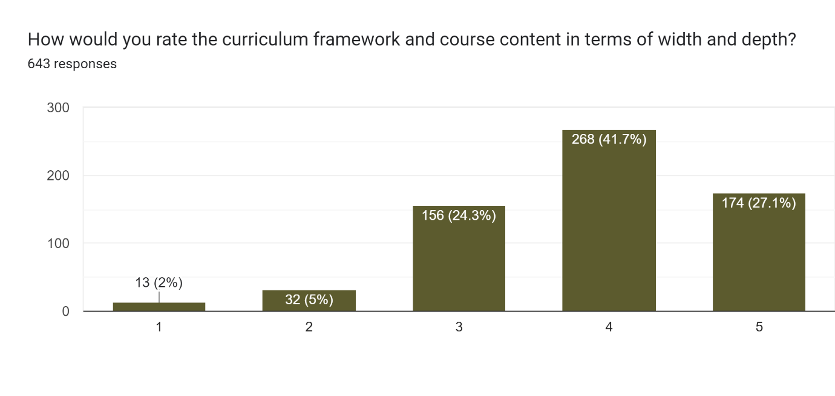

Note: NR represents the cases where the course name is not revealed.

More than 80% students of in the individual courses like honours in Bengali, Botany, Mathematics, Music and B.Sc. Life Sciences have ranked their course content either 4 or 5. But it is the perception of only 50-60% of students in the individual courses like B.Sc. Physical Sciences with Computer/ Multidisciplinary, B.A. (Hons) in Philosophy, English, Geography and Sociology and B.A. Program/ Multidisciplinary.

## Counselling and mentorship:

While the maximum (more than 64%) students across the courses have accepted that adequate counselling was provided to help them to choose their optional papers, nearly 19% students have expressed their need for more support. Around 17.6% respondents have mentioned the mentoring or counselling was not useful at all in choosing their optional especially generic elective papers.

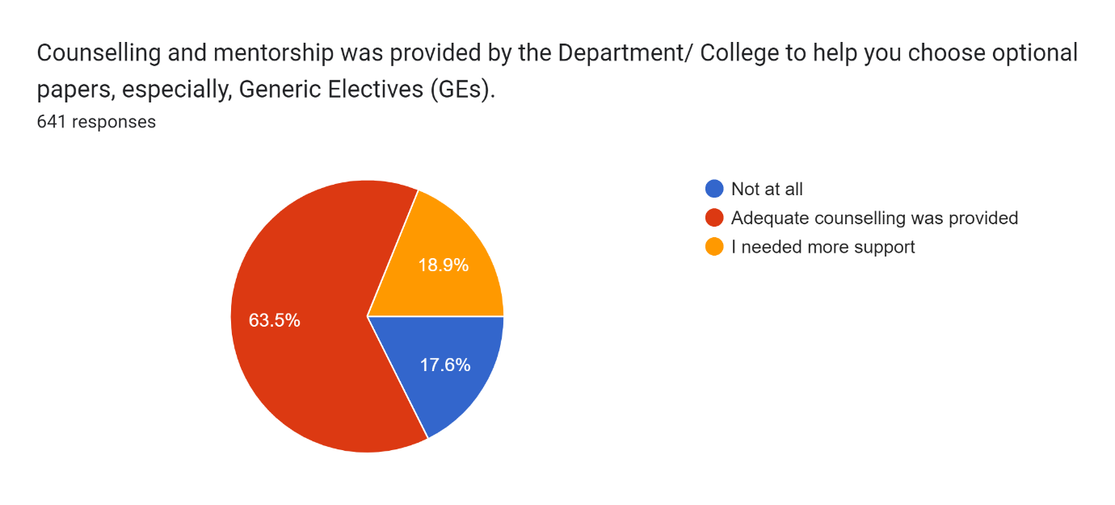

Across all the courses majority of the respondents have expressed that the counselling was adequate.

|  |  |  |
| --- | --- | --- |
|  | **Adequate counselling was provided (% in total respondents course-wise)** | **Inference** |
| Not Responded (i.e. Not Disclosed the Department Name) | 100.0 | Courses where at least 75% students perceive that counselling was adequate |
| B.A. (Hons) Music Count | 100.0 |
| B.A. (Hons) Sanskrit Count | 83.3 |
| B.A. (Hons) Political Science Count | 82.6 |
| B.A. (Hons) Geography Count | 78.6 |
| B.A. (Hons) English Count | 76.9 |
| B.Sc. (Hons) Mathematics Count | 74.4 | Courses where 60- 75% students perceive that counselling was adequate |
| B.A. (Hons) Bengali Count | 70.0 |
| B.A. (Hons) Philosophy Count | 68.9 |
| B.Sc. (Hons) Botany Count | 64.3 |
| B.Sc. (Hons) Physics Count | 63.6 |
| B.A. (Hons) Hindi Count | 61.9 |
| B.Sc. (Hons) Chemistry Count | 61.4 |
| B.Sc. Life Sciences / Multidisciplinary Count | 60.6 |
| B.A. (Hons) Economics Count | 58.8 | Courses where 44.5-60% students perceive that counselling was adequate |
| B.Sc. (Hons) Zoology Count | 55.7 |
| B.Sc. Physical Sciences with Computer/ Multidisciplinary Count | 54.5 |
| B.A. Program/ Multidisciplinary Count | 53.1 |
| B.A. (Hons) History Count | 52.0 |
| B.A. (Hons) Sociology Count | 50.0 |
| B.El.Ed Count | 44.4 |

|  |  |  |
| --- | --- | --- |
|  | **Not at all adequate (% in total respondents course-wise)** |  |
| B.A. (Hons) Sociology Count | 35.71 | Courses where between 20-36% students perceive that counselling was not at all adequate |
| B.Sc. (Hons) Botany Count | 26.19 |
| B.Sc. (Hons) Zoology Count | 25.71 |
| B.A. Program/ Multidisciplinary Count | 25.00 |
| B.Sc. Life Sciences / Multidisciplinary Count | 24.24 |
| B.Sc. Physical Sciences with Computer/ Multidisciplinary Count | 22.73 |
| B.A. (Hons) Hindi Count | 22.22 |
| B.El.Ed Count | 22.22 |
| B.A. (Hons) Philosophy Count | 18.03 | Courses where 9-20% students perceive that counselling was not adequate |
| B.A. (Hons) History Count | 16.00 |
| B.Sc. (Hons) Chemistry Count | 15.91 |
| B.A. (Hons) Geography Count | 14.29 |
| B.A. (Hons) Bengali Count | 10.00 |
| B.Sc. (Hons) Physics Count | 9.09 |
| B.A. (Hons) Political Science Count | 8.70 | Courses where only 0-9% students perceive that counselling was not adequate |
| B.A. (Hons) English Count | 7.69 |
| B.A. (Hons) Sanskrit Count | 4.17 |
| NR Count | 0.00 |
| B.A. (Hons) Music Count | 0.00 |
| B.Sc. (Hons) Mathematics Count | 0.00 |
| B.A. (Hons) Economics Count | 0.00 |

|  |  |  |
| --- | --- | --- |
|  | **I needed more support (% in total respondents course-wise)** |  |
| B.A. (Hons) Economics Count | 41.2 | Courses where between 23-41% students perceive that they need more support |
| B.El.Ed Count | 33.3 |
| B.A. (Hons) History Count | 32.0 |
| B.Sc. (Hons) Physics Count | 27.3 |
| B.Sc. (Hons) Mathematics Count | 25.6 |
| B.Sc. (Hons) Chemistry Count | 22.7 | Courses where between 13-23% students perceive that they need more support |
| B.Sc. Physical Sciences with Computer/ Multidisciplinary Count | 22.7 |
| B.A. Program/ Multidisciplinary Count | 21.9 |
| B.A. (Hons) Bengali Count | 20.0 |
| B.Sc. (Hons) Zoology Count | 18.6 |
| B.A. (Hons) Hindi Count | 15.9 |
| B.A. (Hons) English Count | 15.4 |
| B.Sc. Life Sciences / Multidisciplinary Count | 15.2 |
| B.A. (Hons) Sociology Count | 14.3 |
| B.A. (Hons) Philosophy Count | 13.1 |
| B.A. (Hons) Sanskrit Count | 12.5 | Courses where less than 13% students perceive that they need more support |
| B.Sc. (Hons) Botany Count | 9.5 |
| B.A. (Hons) Political Science Count | 8.7 |
| B.A. (Hons) Geography Count | 7.1 |
| Not Responded (i.e. Not Disclosed the Department Name) | 0.0 |
| B.A. (Hons) Music Count | 0.0 |

## Preparedness of teachers for classes

Nearly 70% respondents in total respondents have ranked teachers’ preparedness for the classes either 4 or 5, though majority among them has ranked 4.

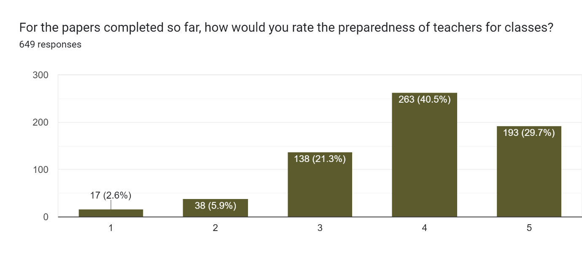

In 14 out of 21 individual courses more than 70% respondents have ranked the preparedness of the teachers as 4 or 5.

|  |  |  |
| --- | --- | --- |
| **Courses** | **Teachers' preparedness for classes with rank 4 or 5 (%in total respondents course-wise)** |  |
| B.A. (Hons) Music Count | 100.0 | Courses where at least 70% students rank teacher preparedness as 4 or 5 |
| B.Sc. (Hons) Mathematics Count | 89.7 |
| Not Responded (i.e. Not Disclosed the Department Name) | 85.7 |
| B.A. (Hons) English Count | 84.6 |
| B.Sc. (Hons) Botany Count | 83.3 |
| B.A. (Hons) Political Science Count | 82.6 |
| B.A. (Hons) Hindi Count | 81.0 |
| B.A. (Hons) Sanskrit Count | 79.2 |
| B.Sc. (Hons) Zoology Count | 77.8 |
| B.Sc. (Hons) Physics Count | 73.9 |
| B.A. (Hons) Bengali Count | 72.7 |
| B.Sc. (Hons) Chemistry Count | 72.7 |
| B.A. (Hons) Economics Count | 70.6 |
| B.Sc. Life Sciences / Multidisciplinary Count | 70.6 |
| B.A. (Hons) Geography Count | 64.3 | Courses where 50-70% students rank teacher preparedness as 4 or 5 |
| B.Sc. Physical Sciences with Computer/ Multidisciplinary Count | 59.1 |
| B.A. (Hons) Philosophy Count | 59.0 |
| B.A. (Hons) History Count | 57.7 |
| B.A. Program/ Multidisciplinary Count | 47.7 | Courses where less than 50-36% students rank teacher preparedness as 4 or 5 |
| B.A. (Hons) Sociology Count | 42.9 |
| B.El.Ed Count | 36.8 |

## Academic Inclusiveness: accommodation of understanding-level differentials among students in classes

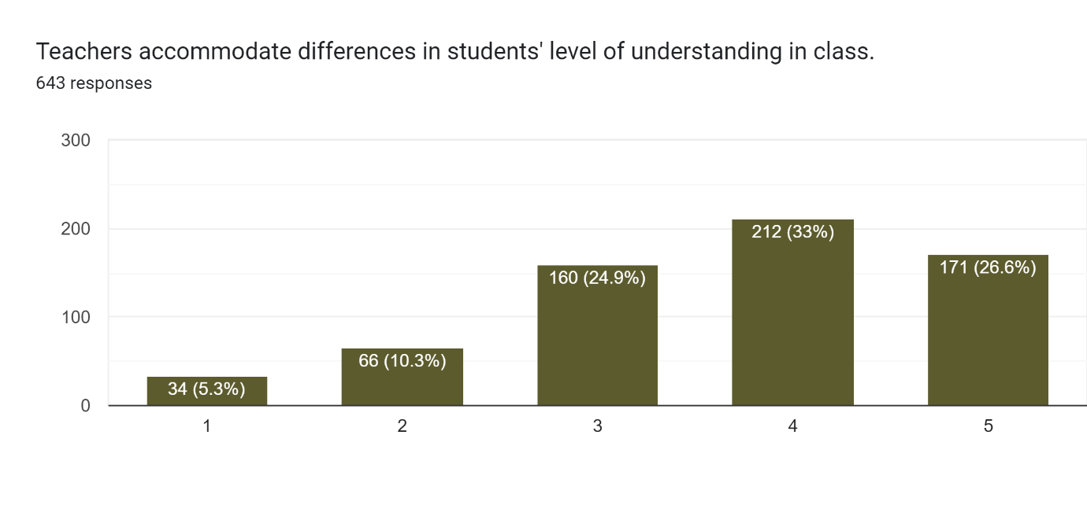

Nearly 60% of respondents perceive that teachers accommodate differences in students’ level of understanding and ranked as 4 or 5.

|  |  |  |
| --- | --- | --- |
| **Courses** | **Teachers accommodate differences in students' level of understanding in class with rank 4 or 5 (%in total respondents course-wise)** |  |
| B.A. (Hons) Music Count | 100.00 | Courses where above 70% students rank academic inclusiveness at higher end |
| Not Responded (i.e. Not Disclosed the Department Name) | 85.71 |
| B.Sc. Life Sciences / Multidisciplinary Count | 76.47 |
| B.A. (Hons) Sanskrit Count | 75.00 |
| B.Sc. (Hons) Mathematics Count | 74.36 |
| B.A. (Hons) Bengali Count | 72.73 |
| B.Sc. Physical Sciences with Computer/ Multidisciplinary Count | 72.73 |
| B.A. (Hons) Hindi Count | 72.58 |
| B.Sc. (Hons) Zoology Count | 67.14 | Courses where 50-70% students rank academic inclusiveness at higher end |
| B.Sc. (Hons) Botany Count | 65.85 |
| B.A. (Hons) Geography Count | 64.29 |
| B.A. (Hons) Political Science Count | 56.52 |
| B.Sc. (Hons) Chemistry Count | 55.81 |
| B.A. (Hons) History Count | 53.85 |
| B.A. (Hons) Economics Count | 52.94 |
| B.Sc. (Hons) Physics Count | 52.17 |
| B.A. Program/ Multidisciplinary Count | 47.69 | Courses where less than 50% students rank academic inclusiveness at higher end |
| B.A. (Hons) English Count | 42.31 |
| B.A. (Hons) Philosophy Count | 41.67 |
| B.El.Ed Count | 36.84 |
| B.A. (Hons) Sociology Count | 28.57 |

## Syllabus coverage in class

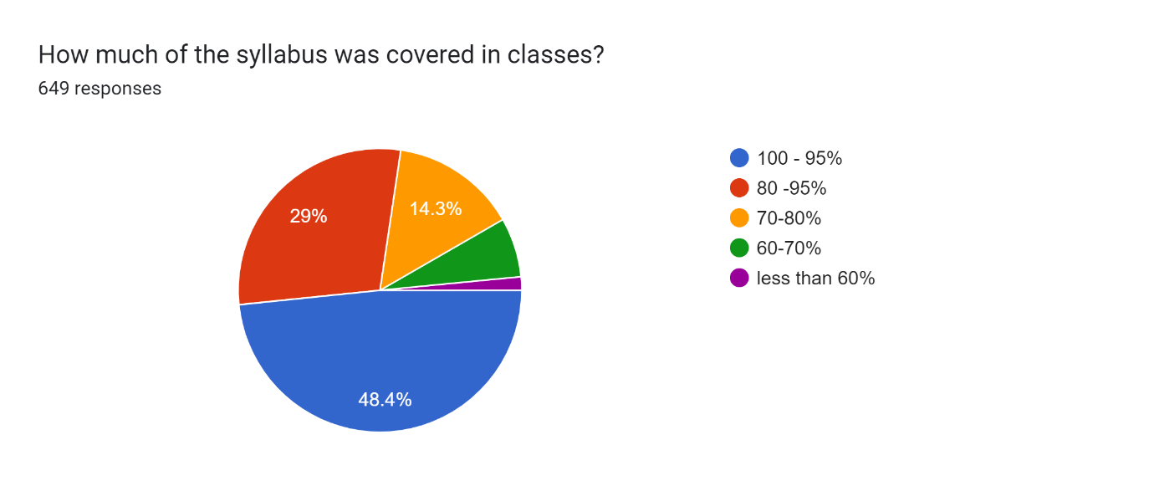

Nearly 80% respondents have revealed that 80-100% syllabus was covered in classes.

In most courses (12 out of mentioned 19 courses), more than 77% students have mentioned that at least 80% syllabus was covered in class.

|  |  |  |
| --- | --- | --- |
| **Courses** | **At least 80% of syllabus was covered in classes (% in total respondents course-wise)** |  |
| B.A. (Hons) Music Count | 100.0 | Courses where more than 75% students agree |
| B.Sc. Physical Sciences with Computer/ Multidisciplinary Count | 95.5 |
| B.Sc. (Hons) Mathematics Count | 94.9 |
| B.A. (Hons) Economics Count | 94.1 |
| B.Sc. (Hons) Botany Count | 92.9 |
| B.A. (Hons) Sanskrit Count | 91.7 |
| B.A. (Hons) English Count | 88.5 |
| B.Sc. (Hons) Zoology Count | 86.1 |
| B.Sc. (Hons) Chemistry Count | 84.1 |
| B.A. (Hons) Political Science Count | 82.6 |
| B.A. (Hons) Geography Count | 78.6 |
| B.A. (Hons) Hindi Count | 77.8 |
| B.A. (Hons) Philosophy Count | 75.4 |
| B.Sc. (Hons) Physics Count | 73.9 | Courses where 50-75% students agree |
| B.A. (Hons) Bengali Count | 72.7 |
| B.Sc. Life Sciences / Multidisciplinary Count | 61.8 |
| B.A. (Hons) History Count | 57.7 |
| Not Responded (i.e. Not Disclosed the Department Name) | 57.1 |
| B.A. Program/ Multidisciplinary Count | 56.9 |
| B.A. (Hons) Sociology Count | 50.0 | Courses where less than 50% students agree |
| B.El.Ed Count | 42.1 |
| Median | 78.6 |  |
| Mean | 76.9 |  |

## Internal Assessment to help in understanding the subject

Near about 77% students have responded that in more than 80% or in all papers the internal assessment was designed to increase their understanding of the subject. For only 9% of the respondents this was done for less than 50% papers. 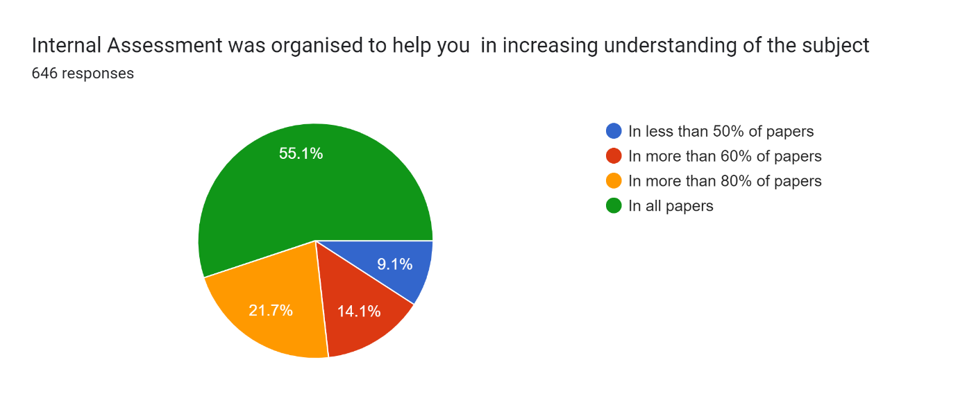

|  |  |  |
| --- | --- | --- |
| **Courses** | **In all or more than 80% papers (%in total respondents course-wise)** |  |
| B.A. (Hons) Bengali Count | 100.0 | Courses where more than 85% students rank at the higher end. |
| B.A. (Hons) Music Count | 100.0 |
| B.Sc. (Hons) Botany Count | 92.7 |
| B.A. (Hons) Political Science Count | 91.3 |
| B.A. (Hons) Sanskrit Count | 87.5 |
| B.Sc. (Hons) Mathematics Count | 86.8 |
| B.Sc. Physical Sciences with Computer/ Multidisciplinary Count | 86.4 |
| Not Responded (i.e. Not Disclosed the Department Name) | 83.3 | Courses where 71-85% students rank at the higher end. |
| B.Sc. Life Sciences / Multidisciplinary Count | 82.4 |
| B.A. (Hons) Philosophy Count | 82.0 |
| B.A. (Hons) Geography Count | 78.6 |
| B.Sc. (Hons) Zoology Count | 77.8 |
| B.Sc. (Hons) Chemistry Count | 77.3 |
| B.A. (Hons) English Count | 73.1 |
| B.A. (Hons) Hindi Count | 69.8 | Courses where 50-71% students rank at the higher end. |
| B.A. Program/ Multidisciplinary Count | 69.2 |
| B.A. (Hons) History Count | 65.4 |
| B.A. (Hons) Economics Count | 64.7 |
| B.El.Ed Count | 57.9 |
| B.Sc. (Hons) Physics Count | 56.5 |
| B.A. (Hons) Sociology Count | 50.0 |
| **Mean** | **77.7** |  |
| **Median** | **78.6** |  |

## Rating of the use of teaching aids and ICT tools

Less than 10% of total respondents have ranked lowest i.e., 1. Nearly 56% of respondents have ranked on higher end, either 4 or 5.

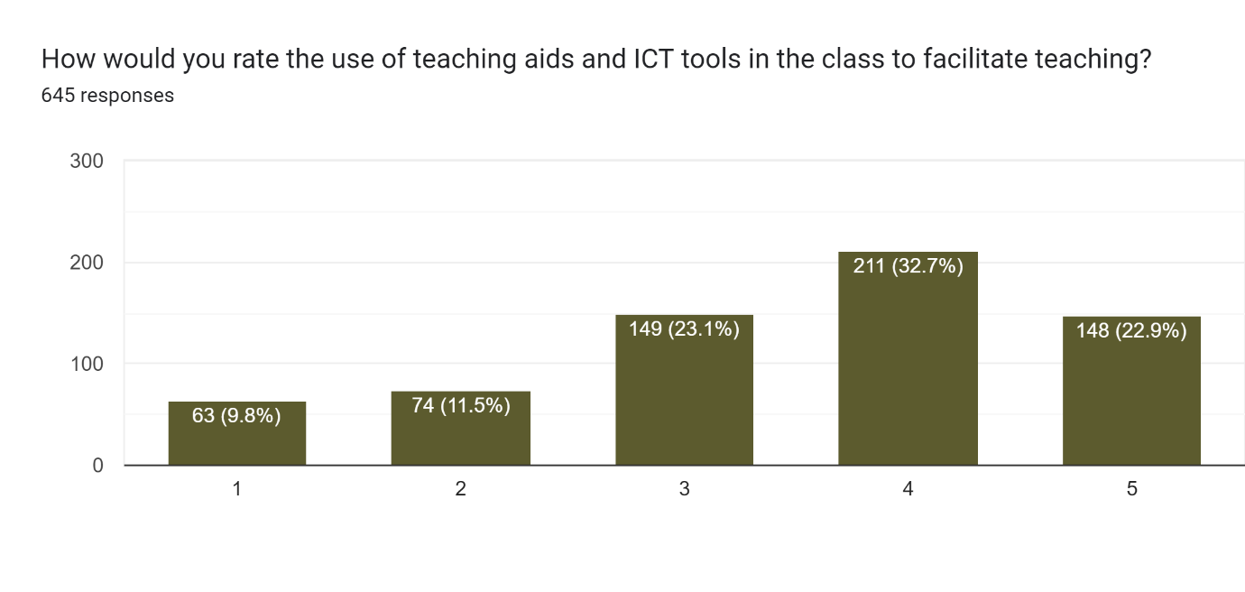

|  |  |  |  |
| --- | --- | --- | --- |
|  |  | **Ranked 4 or 5 (%in total respondents course-wise)** |  |
| B.A. (Hons) Music Count | 1 | 100.0 | Courses where above 70% students rank the use of teaching aids and ICT tools at the higher end. |
| B.Sc. (Hons) Botany Count | 35 | 83.3 |
| B.Sc. Life Sciences / Multidisciplinary Count | 28 | 82.4 |
| B.Sc. (Hons) Chemistry Count | 34 | 77.3 |
| B.Sc. (Hons) Zoology Count | 53 | 73.6 |
| B.A. (Hons) Bengali Count | 8 | 72.7 |
| B.A. (Hons) Sanskrit Count | 17 | 70.8 |
| B.Sc. Physical Sciences with Computer/ Multidisciplinary Count | 15 | 68.2 | Courses where 50-70% students rank the use of teaching aids and ICT tools at the higher end. |
| B.A. (Hons) Hindi Count | 39 | 62.9 |
| B.Sc. (Hons) Mathematics Count | 22 | 57.9 |
| Not Responded (i.e. Not Disclosed the Department Name) | 4 | 57.1 |
| B.Sc. (Hons) Physics Count | 13 | 56.5 |
| B.A. (Hons) Geography Count | 7 | 50.0 |
| B.A. (Hons) Political Science Count | 9 | 39.1 | Courses where less than 50% students rank the use of teaching aids and ICT tools at the higher end. |
| B.A. Program/ Multidisciplinary Count | 25 | 38.5 |
| B.El.Ed Count | 7 | 36.8 |
| B.A. (Hons) Economics Count | 6 | 35.3 |
| B.A. (Hons) Philosophy Count | 21 | 34.4 |
| B.A. (Hons) History Count | 8 | 32.0 |
| B.A. (Hons) Sociology Count | 3 | 21.4 |
| B.A. (Hons) English Count | 2 | 8.0 |
| **Mean** |  | **55.2** |  |
| **Median** |  | **57.1** |  |

More than 55% of the students in most courses have ranked the use of teaching aid and ICT tools have ranked either 4 or 5.

## Learning opportunities through Seminars, conference, presentation, workshops etc.

More than 66% of the respondents have ranked the status of learning through seminars, workshops etc at the higher end, either 4 or 5 in their courses. Only 21% have ranked at 3.

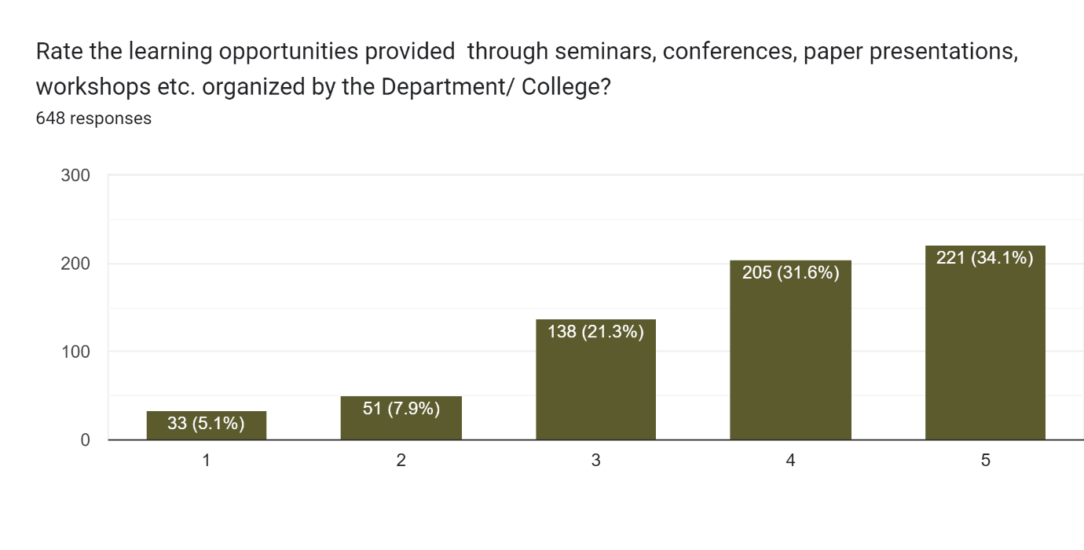

|  |  |  |
| --- | --- | --- |
|  | **Ranked 4 or 5(% in total respondents course-wise)** |  |
| B.A. (Hons) Music Count | 100.0 | Courses where at least 70% students perceive the opportunities of learning through seminars, workshops etc at the higher end. |
| Not Responded (i.e. Not Disclosed the Department Name) | 100.0 |
| B.A. (Hons) Geography Count | 85.7 |
| B.Sc. Life Sciences / Multidisciplinary Count | 85.3 |
| B.A. (Hons) Bengali Count | 81.8 |
| B.A. (Hons) Sanskrit Count | 79.2 |
| B.Sc. (Hons) Physics Count | 73.9 |
| B.Sc. (Hons) Zoology Count | 73.6 |
| B.Sc. (Hons) Mathematics Count | 68.4 | Courses where 50-70% students perceive the opportunities of learning through seminars, workshops etc at the higher end. |
| B.A. (Hons) Hindi Count | 68.3 |
| B.Sc. (Hons) Chemistry Count | 68.2 |
| B.Sc. Physical Sciences with Computer/ Multidisciplinary Count | 68.2 |
| B.A. (Hons) Political Science Count | 65.2 |
| B.Sc. (Hons) Botany Count | 65.1 |
| B.A. (Hons) Economics Count | 64.7 |
| B.El.Ed Count | 63.2 |
| B.A. (Hons) History Count | 57.7 |
| B.A. Program/ Multidisciplinary Count | 56.9 |
| B.A. (Hons) Philosophy Count | 50.0 |
| B.A. (Hons) Sociology Count | 50.0 |
| B.A. (Hons) English Count | 30.8 | Courses where less than 50% students perceive the opportunities of learning through seminars, workshops etc at the higher end. |
| **Mean** | **71.3** |  |
| **Median** | **68.2** |  |

## Adequacy of departmental Mentor-Mentee programme

More than 65% of the total respondents were under the view that the mentor-mentee programme provided by their department are adequate.

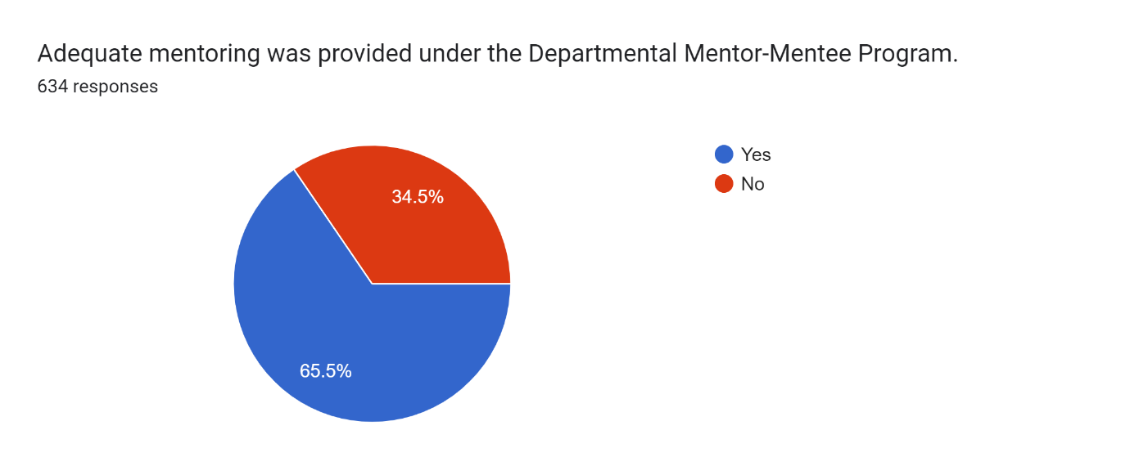

In most of the courses more than 67% respondents have revealed the mentor-mentee programme, provided by their departments were adequate.

|  |  |  |
| --- | --- | --- |
|  | **Yes, adequate (% in total respondents course-wise)** |  |
| B.A. (Hons) Bengali Count | 100.0 | Courses where at least 70% students perceive that the mentor-mentee programme is adequate |
| B.A. (Hons) Music Count | 100.0 |
| B.Sc. (Hons) Botany Count | 88.1 |
| B.A. (Hons) Sanskrit Count | 87.0 |
| B.Sc. Life Sciences / Multidisciplinary Count | 85.3 |
| B.Sc. (Hons) Mathematics Count | 79.5 |
| B.Sc. (Hons) Zoology Count | 73.5 |
| B.A. (Hons) Geography Count | 71.4 |
| B.A. (Hons) Economics Count | 70.6 |
| B.Sc. (Hons) Chemistry Count | 69.8 | Courses where 50-70% students perceive that the mentor-mentee programme is adequate |
| B.A. (Hons) Political Science Count | 69.6 |
| B.Sc. (Hons) Physics Count | 69.6 |
| B.A. (Hons) Hindi Count | 65.0 |
| B.Sc. Physical Sciences with Computer/ Multidisciplinary Count | 59.1 |
| Not Responded (i.e. Not Disclosed the Department Name) | 57.1 |
| B.A. (Hons) English Count | 56.0 |
| B.A. (Hons) Philosophy Count | 51.7 |
| B.A. (Hons) Sociology Count | 46.2 | Courses where 36-50% students perceive that the mentor-mentee programme is adequate |
| B.A. (Hons) History Count | 41.7 |
| B.A. Program/ Multidisciplinary Count | 40.6 |
| B.El.Ed Count | 36.8 |
| **Mean** | **67.5** |  |
| **Median** | **69.6** |  |

# **Infrastructure**

## Infrastructure including Lecture Rooms, Library, Computer Labs and Teaching Labs

## 

## College website and acadME app in helping you to remain updated with important information related to internal assessment, attendance, examinations, scholarships etc.

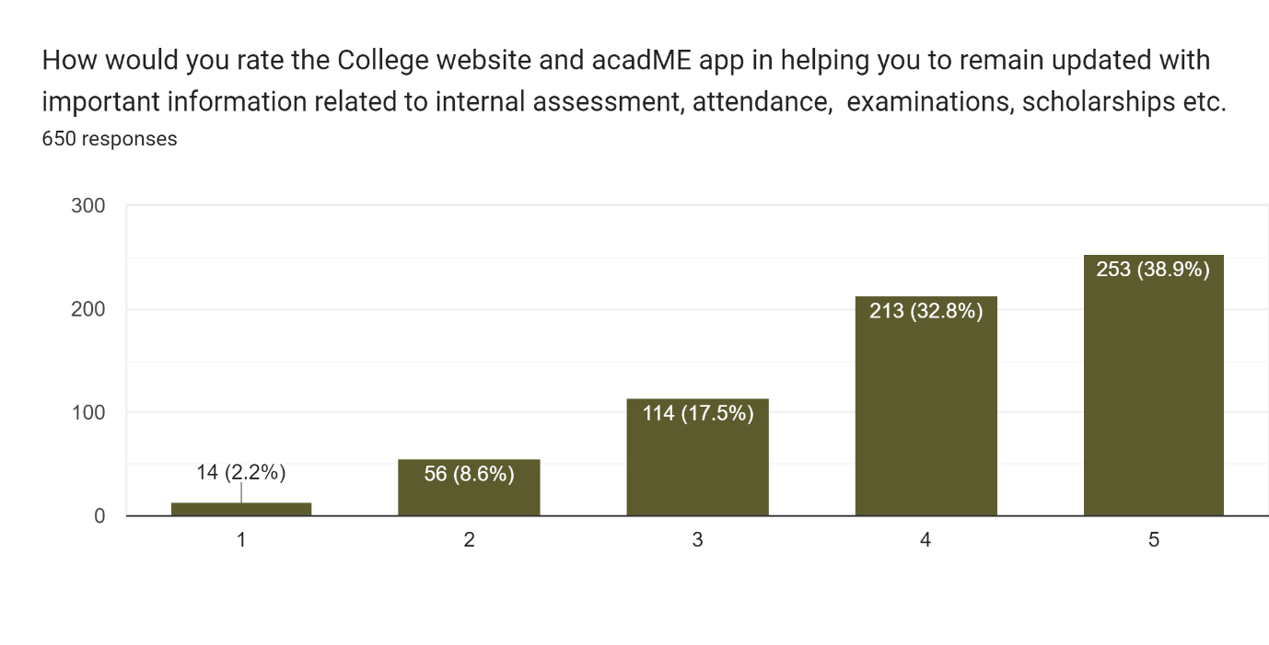

## Washrooms in College

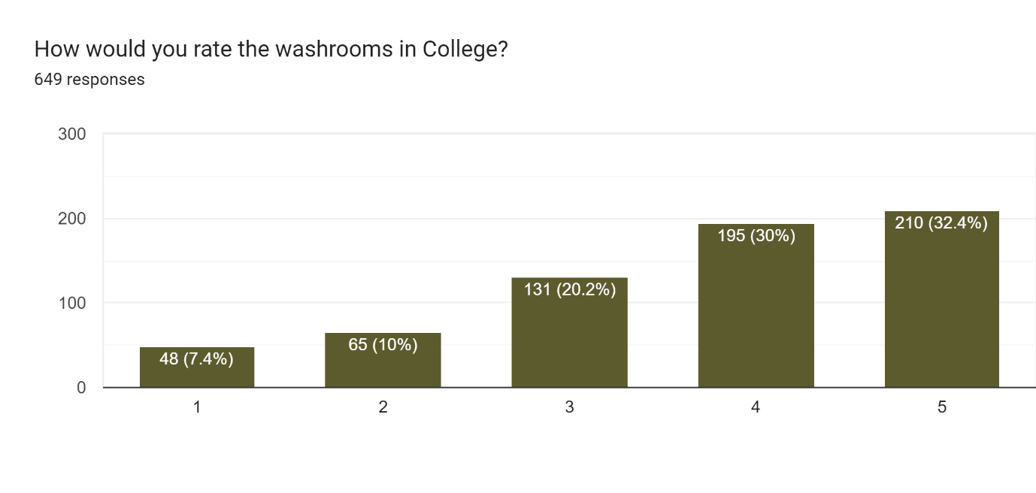

## Availability of clean drinking water

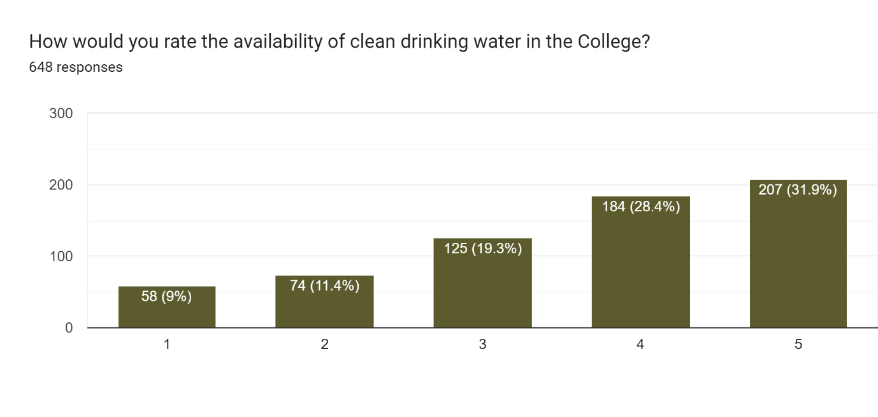

## College canteen

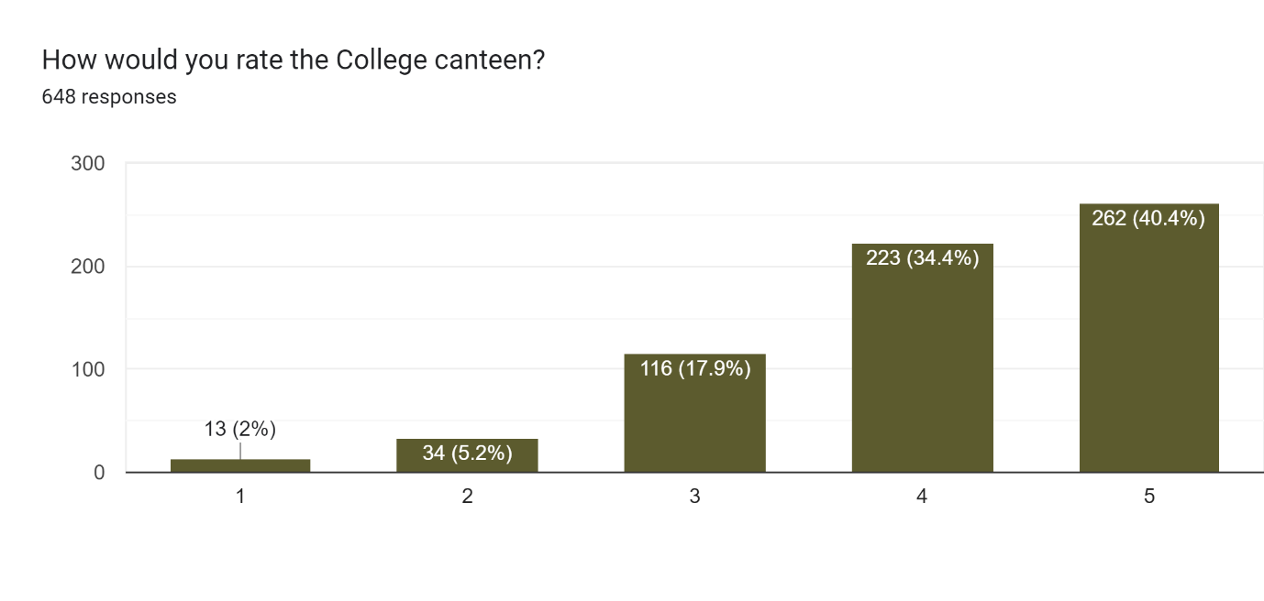

## College gym, if used

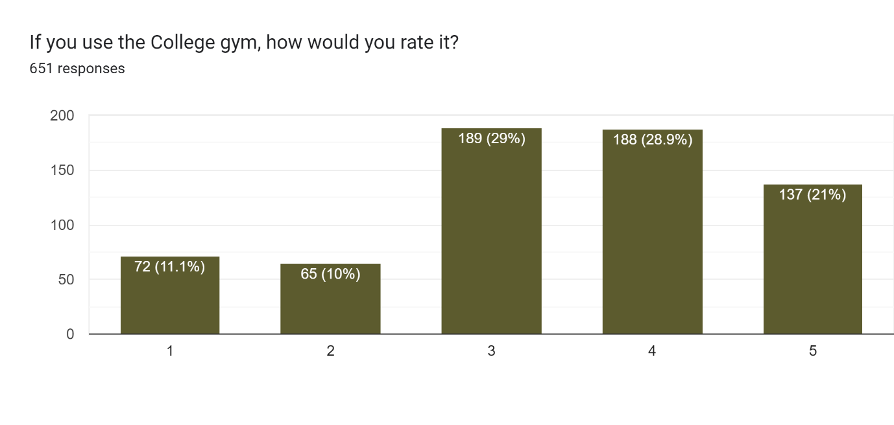

## Over-all experience as a Miranda House hostel resident

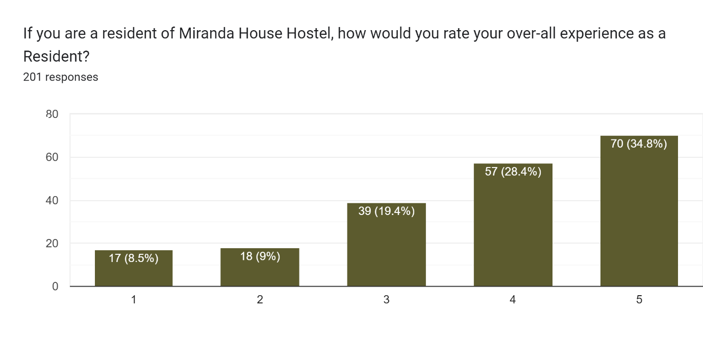

**Student perception about college infrastructure**

|  |  |
| --- | --- |
| **Criteria regarding college infrastructure** | **Ranked 4 or 5 (% of total respondents)** |
| 1. Lecture Rooms, Library, Computer Labs and Teaching Labs | 79.7 |
| 5. College canteen | 74.8 |
| 2. College website and acadME app | 71.7 |
| 7. Over-all experience as a Miranda House hostel resident | 63.2 |
| 3. Washrooms in College | 62.4 |
| 4. Availability of clean drinking water | 60.3 |
| 6. College gym, if used | 49.9 |

Academic infrastructure is a main pillar of an educational institute. About 80% of the respondents have ranked them highly, either 4 or 5. More than 75% of the respondents have expressed their satisfaction, giving a higher rank. Similarly, college website and acadME app could able to keep the students updated satisfactorily, more than 72% of the respondents ranked either 4 or 5. But in case of washroom and availability of clean drinking water, the college has to work more. The student who has used gym, only 50% of them perceived it as a high-end facility. The over-all experience of the hostellers could be addressed in future as the college is also concerned about those 17.5% students who ranked it either 1 or 2.

# **Awareness of grievance redressal, scholarship etc.**

## Awareness of various grievance redressal mechanisms

Nearly 58% of the respondent across courses are aware of various grievance redressal mechanisms.

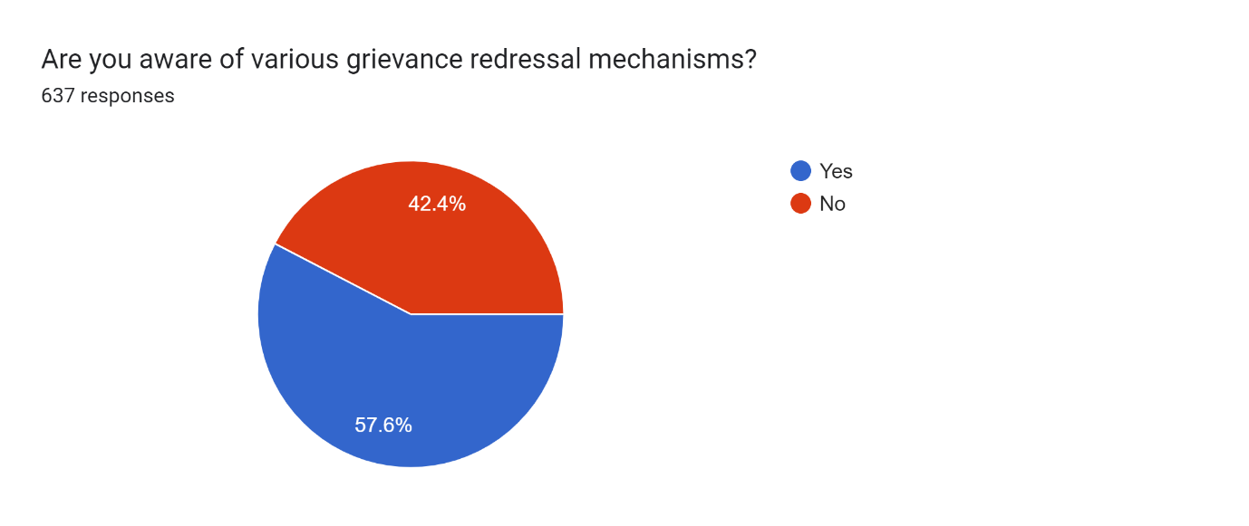

|  |  |  |
| --- | --- | --- |
| **Course** | **Yes (% in total respondents course-wise)** | **Inference** |
| B.A. (Hons) Music Count | 100.0 | Courses where at least 70% students are aware of various grievance redressal mechanism |
| B.A. (Hons) Geography Count | 85.7 |
| B.A. (Hons) Political Science Count | 73.9 |
| B.A. (Hons) English Count | 69.2 | Courses where 50-70% students are aware of various grievance redressal mechanism |
| B.Sc. Life Sciences / Multidisciplinary Count | 67.6 |
| B.Sc. (Hons) Mathematics Count | 65.7 |
| B.A. (Hons) Economics Count | 62.5 |
| B.A. (Hons) Philosophy Count | 58.3 |
| B.A. (Hons) Sociology Count | 57.1 |
| B.Sc. (Hons) Zoology Count | 57.1 |
| B.Sc. Physical Sciences with Computer/ Multidisciplinary Count | 54.5 |
| B.Sc. (Hons) Botany Count | 53.7 |
| B.A. (Hons) Hindi Count | 53.2 |
| B.A. (Hons) History Count | 50.0 |
| B.El.Ed Count | 47.4 | Courses where less than 50% students are aware of various grievance redressal mechanism |
| B.Sc. (Hons) Chemistry Count | 46.5 |
| Not Responded (i.e. Not Disclosed the Department Name) | 42.9 |
| B.A. (Hons) Bengali Count | 27.3 |
| B.A. (Hons) Sanskrit Count | 0.0 |
| B.A. Program/ Multidisciplinary Count | 0.0 |
| B.Sc. (Hons) Physics Count | 0.0 |
| **Mean** | **51.1** |  |
| **Median** | **54.5** |  |

In most of the courses, more than 51% respondents are aware of the various grievance redressal mechanism. Nearly 43% of the respondents who have not revealed their course name, have expressed their awareness positively.

## Awareness of professionally trained guidance and counselling unit to overcome stress

More than 73% of the respondents are aware of that fact that the college has a guidance and counselling unit run by a professionally trained counsellor. Nearly 13% of the respondents have availed the help. Lower ratio of availing the help may also reflect that less number of students required that facility. So, awareness is important whether they have availed it or not.

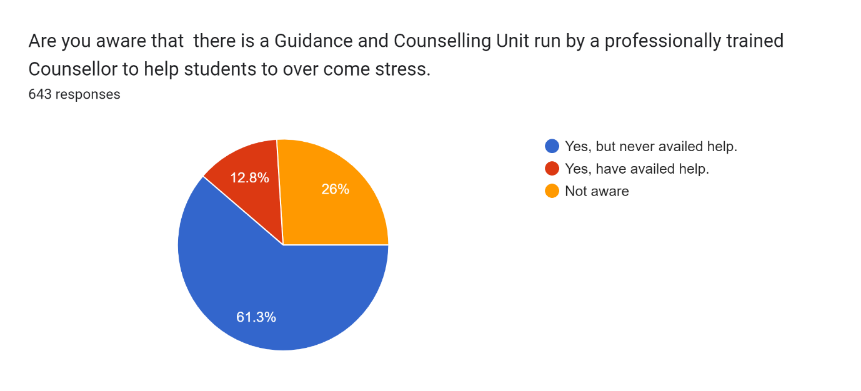

In 50% of the courses, above 71% of respondents are aware of the unit.

|  |  |  |
| --- | --- | --- |
| **Courses** | **Aware of professional counselling unit (% in total respondents course-wise)** |  |
| B.A. (Hons) Music Count | 100.0 | Courses where at least 70% students are aware. |
| B.Sc. Life Sciences / Multidisciplinary Count | 88.6 |
| B.A. (Hons) Political Science Count | 87.5 |
| B.Sc. (Hons) Botany Count | 83.3 |
| B.A. (Hons) Geography Count | 80.0 |
| B.Sc. (Hons) Zoology Count | 78.1 |
| B.Sc. (Hons) Mathematics Count | 73.7 |
| B.A. (Hons) Sociology Count | 73.3 |
| B.A. (Hons) Bengali Count | 72.7 |
| B.A. (Hons) Philosophy Count | 72.6 |
| Not Responded (i.e. Not Disclosed the Department Name) | 71.4 |
| B.A. (Hons) Economics Count | 70.6 |
| B.Sc. Physical Sciences with Computer/ Multidisciplinary Count | 69.6 | Courses where 60-70% students are aware |
| B.A. Program/ Multidisciplinary Count | 68.2 |
| B.A. (Hons) English Count | 66.7 |
| B.Sc. (Hons) Chemistry Count | 66.7 |
| B.A. (Hons) Hindi Count | 65.1 |
| B.A. (Hons) History Count | 63.0 |
| B.Sc. (Hons) Physics Count | 62.5 |
| B.A. (Hons) Sanskrit Count | 60.0 |
| B.El.Ed Count | 60.0 |
| **Mean** | **73.0** |  |
| **Median** | **71.4** |  |

# **Overall development of students**

## The efforts of the College/teachers in providing opportunities for a holistic development of students

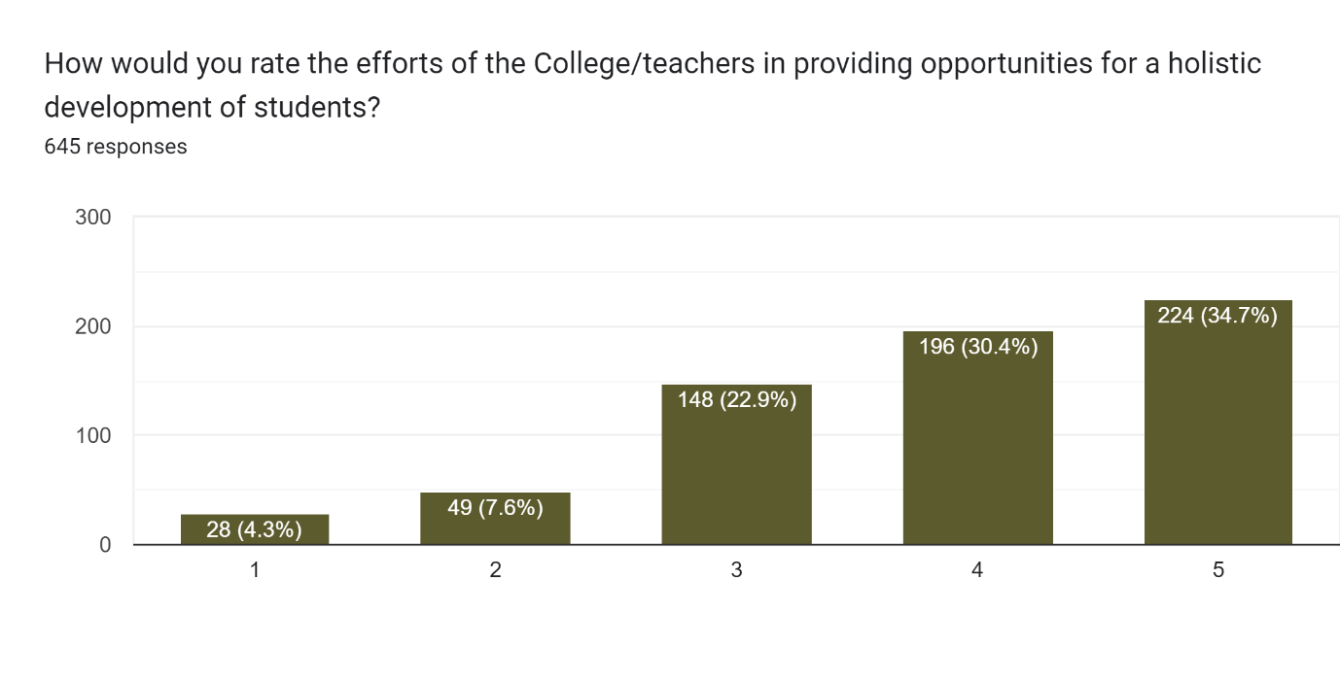

Nearly 65% of respondents have ranked the college/teacher initiative for the holistic development of the students at the higher end, 4 or 5.

|  |  |  |
| --- | --- | --- |
| **Courses** | **Ranking of college/teachers initiatives for their holistic development highly (4 or 5) (% in total respondents course-wise)** | **Inference** |
| B.A. (Hons) Music Count | 100.0 | Courses where at least 80% students have ranked at the higher end |
| B.A. (Hons) Hindi Count | 92.3 |
| B.Sc. (Hons) Mathematics Count | 92.3 |
| B.Sc. Life Sciences / Multidisciplinary Count | 91.4 |
| B.A. (Hons) Political Science Count | 87.5 |
| NR Count | 85.7 |
| B.A. (Hons) Sanskrit Count | 84.0 |
| B.A. (Hons) Bengali Count | 83.3 |
| B.Sc. (Hons) Botany Count | 83.3 |
| B.Sc. (Hons) Zoology Count | 83.3 |
| B.A. (Hons) Geography Count | 80.0 | Courses where 70-80% students have ranked at the higher end |
| B.Sc. (Hons) Chemistry Count | 77.8 |
| B.Sc. (Hons) Physics Count | 75.0 |
| B.Sc. Physical Sciences with Computer/ Multidisciplinary Count | 73.9 |
| B.A. Program/ Multidisciplinary Count | 73.8 |
| B.A. (Hons) Economics Count | 72.2 |
| B.A. (Hons) Philosophy Count | 69.4 | Courses where 55-70% students have ranked at the higher end |
| B.A. (Hons) Sociology Count | 66.7 |
| B.El.Ed Count | 65.0 |
| B.A. (Hons) History Count | 63.0 |
| B.A. (Hons) English Count | 55.6 |
| Mean | 78.8 |  |
| Median | 80.0 |  |

In 50% courses, more than 80% of respondents have ranked the college/teachers initiatives for their holistic development highly(4 or 5).

## Overall experience studying at Miranda House

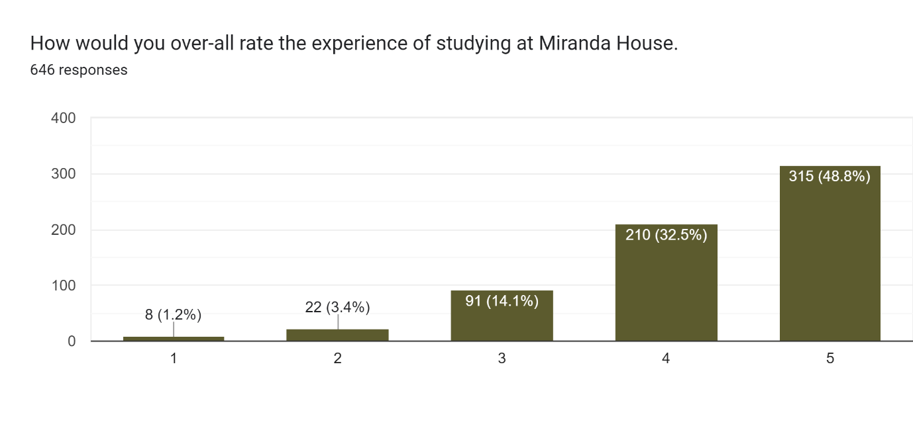

Nealy 82% of the respondents have ranked highly their overall experience in the college.

|  |  |  |
| --- | --- | --- |
| **Courses** | **Higher ranking of overall experience, 4 or 5 (% in total respondents course-wise)** | **Inference** |
| B.A. (Hons) Music Count | 100.0 | Courses where at least 84% students have ranked at the higher end |
| B.Sc. (Hons) Mathematics Count | 94.7 |
| B.Sc. Life Sciences / Multidisciplinary Count | 94.1 |
| B.A. (Hons) Hindi Count | 93.8 |
| B.A. (Hons) Political Science Count | 91.3 |
| B.A. (Hons) Bengali Count | 90.9 |
| B.A. (Hons) Sanskrit Count | 87.5 |
| B.A. (Hons) Geography Count | 85.7 |
| Not Responded (i.e. Not Disclosed the Department Name) | 85.7 |
| B.Sc. (Hons) Botany Count | 85.4 |
| B.Sc. (Hons) Zoology Count | 84.5 |
| B.Sc. (Hons) Chemistry Count | 79.5 | Courses where 70-84% students have ranked at the higher end |
| B.Sc. (Hons) Physics Count | 78.3 |
| B.Sc. Physical Sciences with Computer/ Multidisciplinary Count | 77.3 |
| B.A. (Hons) Economics Count | 76.5 |
| B.A. Program/ Multidisciplinary Count | 75.0 |
| B.A. (Hons) Sociology Count | 71.4 |
| B.A. (Hons) Philosophy Count | 70.5 |
| B.El.Ed Count | 68.4 | Courses where 58-70% students have ranked at the higher end |
| B.A. (Hons) History Count | 65.4 |
| B.A. (Hons) English Count | 57.7 |
| **Mean** | **81.6** |  |
| **Median** | **84.5** |  |

In 50% of courses, more than 85% of the respondents have ranked their overall experience at the higher end.